**“Labour Wage and Associated Factors”-** A Study Based on The Association Between Labour wage and Related Factors Like Usual Working Hour, Total Work Experience and Tenure.

By

**[Aniket Das]**

An assignment for the internal assessment of Economics of Institution special paper

Department of Economics. UNIVERSITY OF CALCUTTA

[Fourth semester,2023]

|  |  |
| --- | --- |
| **NAME:** | ANIKET DAS |
| **CLASS ROLL NUMBER:** | 021 |
| **UNIVERSITY ROLL NUMBER:** | C93_ECO_211031 |
| **REGISTRATION NUMBER:** | 012-1112-0947-18 |
| **SUBJECT:** | ECONOMICS OF INSTITUTION |
| **EMAIL ID:** | DANIKET487@GMAIL.COM |
| **MOBILE NUMBER:** | 9903356539 |
| **DATE:** | 25/5/2023 |

**Abstract:**

In this project, I delved into the intricate relationship between labour wages and various influencing factors. The objective was to comprehensively analyse the determinants that impact wages across different industries and demographics. By examining this multifaceted landscape, we aimed to gain valuable insights into the dynamics of labour compensation and its implications for workforce management, economic policies, and social equity. This is a study where we will see the association between labour wage and other factors (usual working hour, total experience and tenure) based on the data of 2246 females taken from 1988 survey. After building up the econometric model and running regression the result, we got that among the 3 independent variables only 2 variables (hours and ttl_exp) are statistically significant as they have “P>|t|” values less than 0.05 or they do not have 0 in their confidence interval and we also got R-square term to be 0.0799. So, in this study we interpreted all these results and discussed about limitations of this study. Keywords: [wage, total hours, total experience, tenure].

**Acknowledgement:**

I would express my heartfelt gratitude and thanks to my supervisors Prof. Sukanta Bhattacharya and Prof. Anirban Mukherjee for all those helps, stimulating suggestions and encouragement throughout the process. I would also like to extend my thanks and appreciation to all who guided me during this assignment whenever I needed.

**Introduction:**

In this project, we delve into the factors influencing labour wages, focusing on total working hours, total work experience, and job tenure as independent variables. Our primary goal is to unravel the intricate relationship between these variables and the labour wage, shedding light on how variations in working hours, experience, and job tenure impact earnings.

By examining these specific determinants, we aim to provide insights into the dynamics of wage determination within the labour market. Understanding how factors such as total working hours, work experience, and job tenure influence wages is crucial for employers, policymakers, and workers alike. This knowledge can inform decisions related to hiring practices, compensation strategies, and career advancement opportunities.

Through rigorous analysis and interpretation of data, we seek to uncover patterns and correlations that elucidate the role of total working hours, work experience, and job tenure in shaping labour wages. By doing so, we aim to contribute to a better understanding of labour market dynamics and provide valuable insights for promoting fair and equitable compensation practices.

Ultimately, this project serves as a stepping stone towards empowering stakeholders with evidence-based knowledge to address wage disparities, enhance labour market efficiency, and foster economic prosperity for workers.

**Studies based on the association between labour wage and related factors:**

|  |  |  |
| --- | --- | --- |
|  | **Studies** | **Basic Findings and Propositions** |
| • | **Hong Ha Nguyen, 15th June, 2019** | * **Labour force, experience has a significance level of 1%.** * **Working environment has a meaningful 5%.** * **Education, skills, ethnicity has a meaningful 10%.** |
| • | **Alin Borah Bortamuly and Kishor Goswami, 1st June, 2012** | ➢ **Factors like education and experience do not have any significant influence on the wage structure of the workers in the handloom industry in Assam.** |
| • | ***Ozturk M., Durdyev S., Aras O. N., & Banaitis A.,*** ***September 13, 2019*** | * **The results show that the labour productivity index positively affects the labour wage, while the effect of unemployment rate is negative in the long run.** |

**Research Question:**

**How factors like total working hour, experience and tenure influence labour wage?**

Here we are trying to find out **how wage is dependent on time at work and other various variables like total experience and tenure.**

**Hypotheses:**

Here, we are taking few hypotheses,

* **Longer working hour affects wage positively.**

* **Having more experience means higher wage.**

* **Tenure has a positive impact on wage.**

**Econometric Model:**

Here we are taking wage (monthly wage) as the dependent variable and other variables such as hours (usual hours worked), ttl_exp(total work experience), tenure (job tenure in years)as independent variable.

So, the econometric model will be,

= ++++

(Here is the intercept and are coefficients of the variables and is the error term.)

**Method of estimation:**

Here we are using OLS (ordinary least square) method to estimate the values of the parameters as the given model is linear and OLS is best linear unbiased estimator (BLUE). In OLS we will minimize the sum of the square of the residuals (RSS), Then we will check if there is any presence of heteroscedasticity in the model. If it is there then to remove it, we will use another estimator known as weighted least square method (WLS).

**Data:**

Now to estimate the parameters we have used the data collected from 2246 females on the survey of 1988 regarding the mentioned variable.

**Estimation and interpretation of the result:**

So here by help of STATA we are regressing the dependent variable on the independent variables and get the result as shown below,

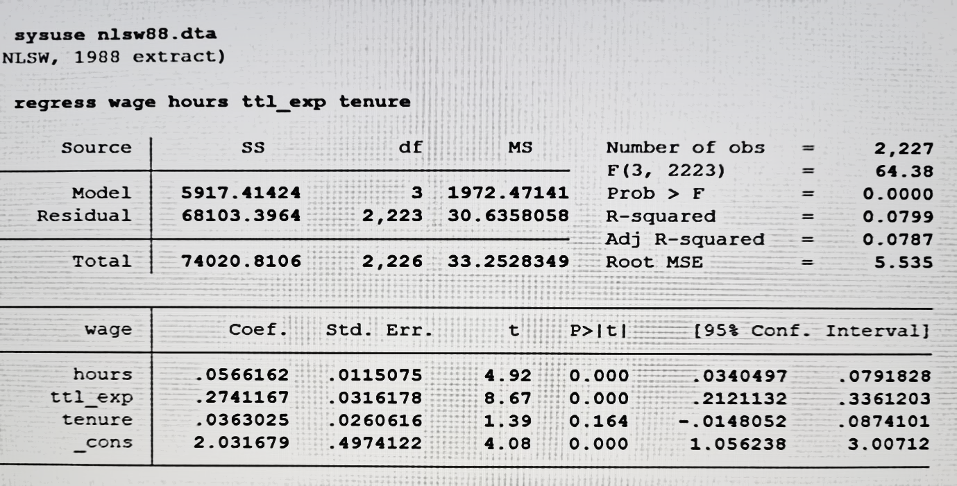

**Results:**

* Coefficient of hours is positive, it means if there is an increase in usual working hours of female, the wage of them will also increase.
* Coefficient of total work experience (ttl_exp) is positive, that means if total work experience increases, their wage will also increase.
* Coefficient of job tenure is also positive, that means if tenure increases wage will also increase.
* **Now we need to see if the variables are individually significant or not**,

So, we can see that out of these 3 independent variables 2 are statistically significant (since their P>|t| values are less than 0.05 or they do not have 0 in their confidence interval.)

Thus, we can see that only ‘hours and ttl_exp’, these two variables are statistically significant.

The values of the independent variables that we get from the regression are shown below,

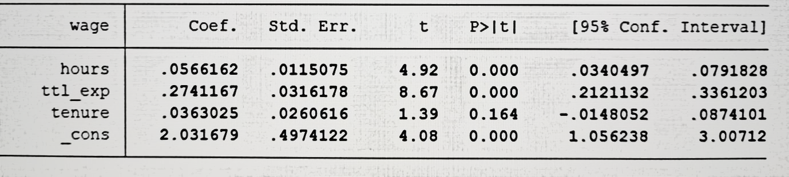

* **Now we need to check if all the variables together are significant or not,**

In order to check that we need see P>F value, here prob>F value of this model is 0.000, that means all the slope parameters are jointly not equal to 0, at least one slope parameter is non-zero in this model. Yes, there is an evidence of regression relationship as 2 independent variables are significant in this model.

By the value of R-squared we can say that this model is capable of explaining approximately 7.99% of the variation in wage (dependent variable).

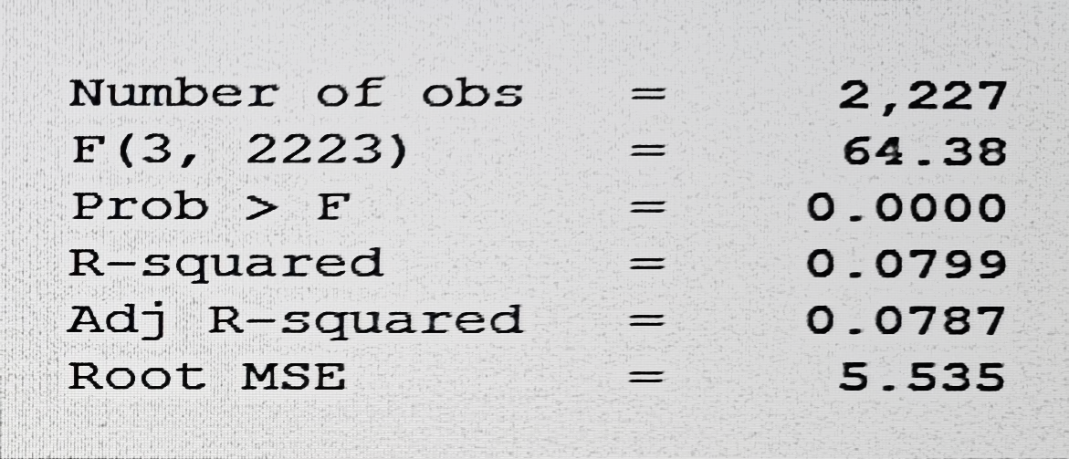

The corresponding values of R-squared and prob>F are shown in this table.

* **Now to check if there is heteroscedasticity in the model, we have taken use of Breusch-**

**Pagan/Cook-Weisberg test of heteroscedasticity,**

So, here from our test we can see that null hypothesis of constant variance is rejected as the Prob > chi2 value is less than 0.05 so we can conclude that the variance of the error term is not constant so there is heteroscedasticity in the model and that is why the estimates obtained above are biased and we cannot rely on those estimates. So, we have to make sure that constant variance is maintained and to maintain this we have to use another estimator which is WLS (weighted least square). Here we assign a weight variable and put weights on the variables then we again run OLS on those weighted variables and in this way estimated values will not be biased anymore as the variance becomes constant.

**Limitations of this study:**

In our project, we explore the intricate relationship between labour wages and key factors such as total working hours, total work experience, and job tenure. By focusing on these independent variables, we aim to uncover insights into how variations in these factors impact individuals' earnings within the labour market but still there are some limitations that we should acknowledge,

* One significant limitation may be the quality and reliability of the data used. Inaccurate or incomplete data on labour wages, working hours, work experience, and job tenure could potentially compromise the validity of our analysis and conclusions.
* While we focus on total working hours, work experience, and job tenure as independent variables, there may be other important factors influencing labour wages that are not included in our analysis. Omitted variables could lead to biased estimates and incomplete understanding of wage determinants.
* Availability of comprehensive data on all relevant variables, especially for job tenure and work experience, may be limited. In some cases, reliance on data from secondary sources may introduce inaccuracies or inconsistencies.
* Labor market conditions and wage determinants may vary over time. Our analysis may not fully capture temporal dynamics, such as economic cycles, policy changes, or technological advancements, which could influence the relationships between labour wages and associated factors.

Acknowledging these limitations is essential for interpreting the findings of our project accurately and understanding the scope and implications of our analysis within the broader context of labour economics.

**Conclusion:**

In wrapping up our project, we've learned a lot about what affects how much people get paid. We found that working more hours generally means higher pay, and as people gain more experience and stay in their jobs longer, their pay tends to go up too.

However, we need to remember that our findings have some limitations. The data we used might not be perfect, and there could be other factors we didn't consider that also play a role in determining wages.

Moving forward, it's important to keep studying this topic to get a clearer picture. By improving our methods and looking at more factors, we can better understand how wages are set and work towards making sure everyone is paid fairly.

Overall, our project adds to the conversation about how to create fairer and more inclusive job markets, where everyone has the opportunity to earn a decent wage.